**Test Driven Development**

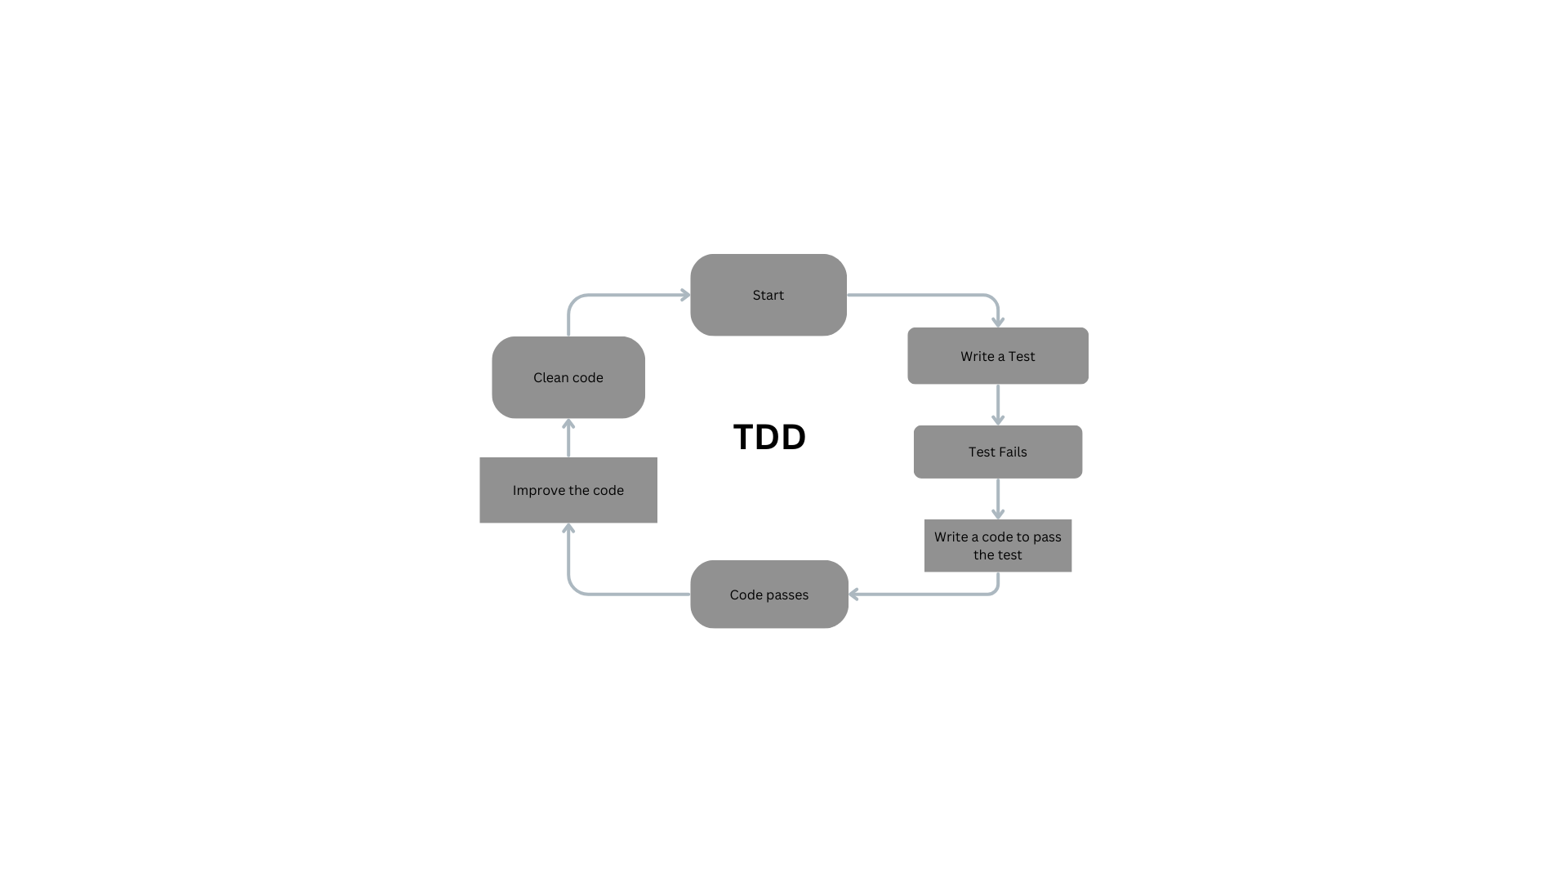

* Test-Driven Development (TDD) is a software development methodology where tests are written before the actual code.
* TDD is a powerful methodology that integrates testing into the development process, leading to higher quality and more maintainable code.

**Step 1: Write a Test**

* **Description**: Begin by writing a test for a new functionality.
* **Goal**: The test should initially fail since the feature hasn’t been implemented yet.
* **Icon/Visual**: A pen writing on a document with a red "X".

**Step 2: Run the Test**

* **Description**: Execute the written test.
* **Goal**: Confirm that the test fails to validate the necessity of the new code.
* **Icon/Visual**: A play button with a red "X".

**Step 3: Write the Code**

* **Description**: Write the minimum amount of code required to pass the test.
* **Goal**: Ensure the new code is focused solely on passing the test.
* **Icon/Visual**: A keyboard typing code with a green checkmark.

**Step 4: Run the Test Again**

* **Description**: Execute the test again.
* **Goal**: Ensure the test passes with the new code.
* **Icon/Visual**: A play button with a green checkmark.

**Step 5: Refactor the Code**

* **Description**: Refactor the new and existing code for optimization and clarity.
* **Goal**: Improve code quality without altering its behaviour.
* **Icon/Visual**: A gear with arrows indicating change.

**Step 6: Repeat**

* **Description**: Repeat the cycle for the next functionality.
* **Goal**: Gradually build a robust, well-tested codebase.
* **Icon/Visual**: A loop arrow indicating continuous process.

**Benefits:**

**1. Bug Reduction**

* **Description**: Early detection of bugs and defects.
* **Icon/Visual**: A bug with a slash through it.

**2. Reliable Codebase**

* **Description**: Ensures code works as intended, improving reliability.
* **Icon/Visual**: A shield with a checkmark.

**3. Better Design**

* **Description**: Promotes simple, modular, and flexible code design.
* **Icon/Visual**: A blueprint or architectural plan.